**BOBJ 4.3**

**Посмотреть источник данных**

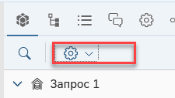

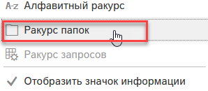

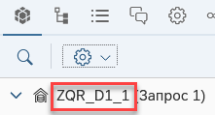

**Редактирование набора атрибутов/показателей**

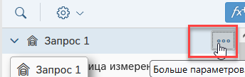

**Фильтр**

**Изменить значения переменных**

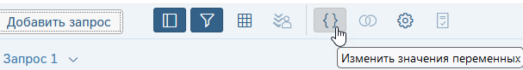

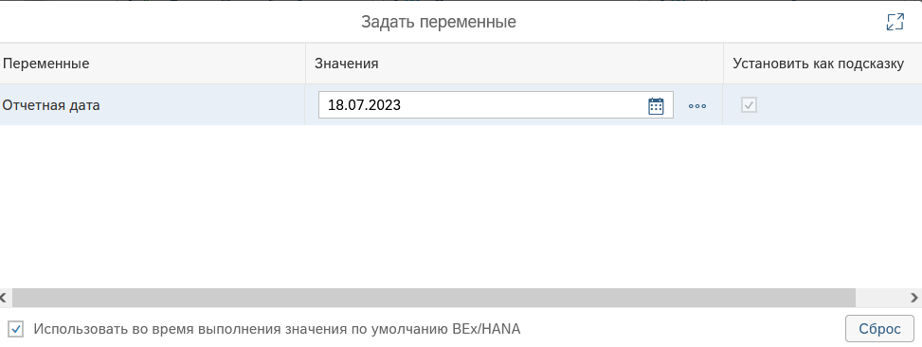

**Добавить запрос**

**График**

Круговая диаграмма - ***Тор***

***Легенда*** /Условные обозначения/ – расположить внизу

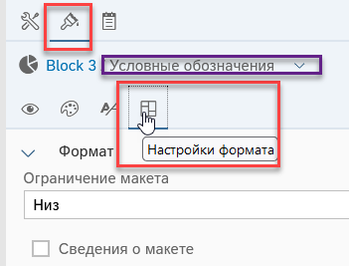

**Гиперссылка** /hyperlink/

The generated syntax of the hyperlink appears in the Formula Bar. Do not modify this syntax directly.

Instead, right-click the cell and click Hyperlink ->Edit Link if you need to update the link.

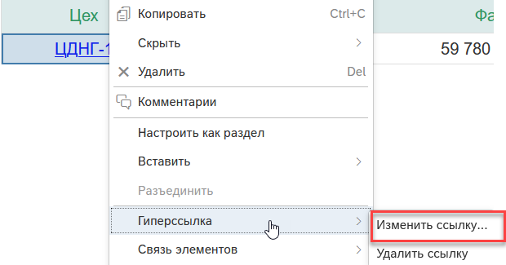

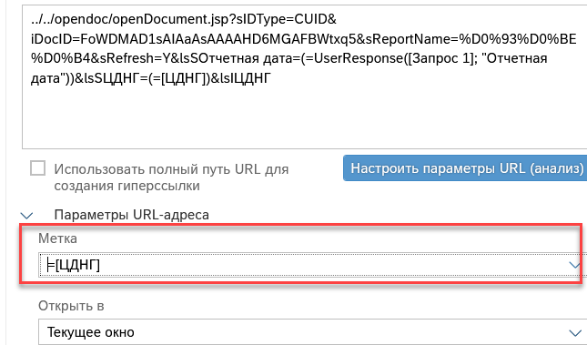

*ЦНГД* = IOBJ ZDEP NUMC(20)

ELEM.REP ZQR_D1_1 <- Композит ZCP_EX

You can create different types of hyperlink

* A cell where the ***cell text*** is the hyperlink text.
* A cell with an ***associated hyperlink***.
* A ***link to another document*** in the CMS.

For target documents that refer to *BEx queries*, *.unx* or *.unv* universes that contain prompts that use Index Awareness, there are additional parameters to set.

* 1. When you create a link, the link is defined using the ***OpenDocument*** syntax. You can also build links manually using *OpenDocument*.

As well as linking between documents, you can also *link report elements* in the same report by defining elements as input controls that filter the values in other report elements.

1. Note
2. Hyperlinks only display as active when your system administrator has authorized them in Web Intelligence.
3. **Cells defined as a hyperlink**

When you define a cell as a hyperlink, the ***cell text*** becomes an active hyperlink.

You define a cell as a hyperlink in a document.

1. In *Design* mode, select or type a hyperlink in a cell.
2. While the cell is selected, click  to open the side panel.
3. In the side panel, click  to open the *Format* panel.
4. Click  to access the appearance settings.
5. Under the *Display* section, select *Hyperlink* in the *Read content as* drop down.

**A hyperlink associated with a cell**

350

When you ***associate a hyperlink*** with a cell, you define a hyperlink that links to the source document when the cell is clicked.

The *cell text* itself is not the hyperlink.

You configure cell hyperlinks

1. In *Design* mode, select a cell and right-click it.
2. In the contextual menu, click *Hyperlink -> Add Hyperlink*.
3. Type or paste the hyperlink in the dedicated field.
4. [Optional] If the URL has paramerters, click *Customize URL Paramerters (Parse)*.
   1. Dynamic hyperlinks have parameters whose values can change. Parameters appear as a name=value combination at the end of the hyperlink after a question mark. For example, the following URL has a reportname parameter, whose value is products:
   2. http://salesandproductreport/default.asp?reportname=products
   3. If the hyperlink is dynamic and has parameters, they're listed in the *Customize URL Parameters* area.
   4. Each parameter has a dedicated field filled with its value and the parameter name above. The static part of the hyperlink, the part without the parameters, is shown above the parameters.

*Drilling on report data*

*P 362*

**Drilling**

You can drill on ***dimensions*** and ***measures***, in *charts*, *tables* and *sections*. You can drill on both hierarchical or non-hierachical data.

To drill, the application relies on

* The ***definition of the hierarchy***, for hierarchical data.
* ***Navigation paths*** set up by the *universe* designer, for non-hierachical data.

When drilling on a dimension to see the data behind a specific result, the information retrieved depends on the values on which you drill. If your report calculates a region’s total sales revenue for a given year where a Sales Revenue measure is calculated based on the State and Year dimensions, drilling on Year displays the sales revenues by state and quarter, because Quarter is the next dimension in the time hierarchy below Year.

When drilling on a measure value, you drill down one level for each related dimension in the report element.

Drilling on ***charts***, using the chart *axes*, chart *legend* and *data bars*, provides you with a graphical explanation of the results.

Depending on your needs, you can decide to drill either on a ***single element***, or on ***multiple elements*** in the report. The ***Synchronize drill on report blocks*** option available in the BI launch pad preferences let you select the way you want to interact with the report and how you want to drive your analysis. You can either focus on a single element, or drive your analysis simultaneously on all elements when drilling.

To enable drilling, click the icon  in the Analyze section of the toolbar, and check ***Drill.***

Restrictions

* You can't use a Navigation path on ***BEx*** queries. Navigation path /previously called the drillpath/ has been replaced by the collapse/expand work flow on the real hierarchy.
* You can only drill on a ***.unv*** or ***.unx*** universe if the drill paths are previously defined in the universe.

***Defining the scope of analysis***

Defining the scope of analysis before drilling allows you to better control the ***amount of information*** the application should retrieve.

* ***An object that’s part of the scope of analysis*** is also part of the query specification ⇒ when you’re reaching that object when drilling up or down, the application doesn’t have to go through the database and run a new query to retrieve the data.
* ***If it’s not part of the scope***, it’s not part of the query, and the application hits the database and runs a new query to retrieve the missing information. When that’s the case, a prompt asks you whether you want to hit the database and bring the missing data to the report.

You can display the scope of analysis pane by clicking the  icon in the query panel.

Defining the scope of analysis is important, as it can impact performance. You can specify the *number of levels* to which you want to drill up or down directly in the scope of analysis panel, if your security profile allows you to do so. If that's not the case, reach out to your BI administrator.

Scope of analysis levels

* ***None*** - disables the scope of analysis.
* ***One*** | ***Two*** | ***Three*** - for each object in the Result Objects pane, one, two or three objects lower down in the hierarchy are included in the query and stored in the cube.
* ***Custom*** - every object you add manually to the scope is included in the query and stored in the cube.

Note

If you plan on drilling out of scope on a ***Geomap chart***, make sure that every additional dimension you specify is matched with a *location*. If no location is indicated, the additional dimensions won't show on the map.

**Drill paths and hierarchies**

***Drill paths*** usually follow the same hierarchy order as the ***classes on a universe***. For example, a class called *Time* typically includes the *[Year]* dimension at the top of the class, followed by the *[Quarter]*, *[Month]*, and *[Week]* dimensions. ***The hierarchies for drill*** within the *Time hierarchy* typically follow the same order, because users want to drill annual results to analyze details for quarter, month, and so on.

However, the universe designer can also define ***custom hierarchies***. You can view the drill paths and hierarchies defined by the universe designer in the query panel. Just click the icon  next to the name of the universe, and select ***Display by Navigation Paths***.